Nicholas Skinner

CS 453

Spring 2019

**Project 8 - ParaView Volume Visualization**

**Volume 3d composite:**

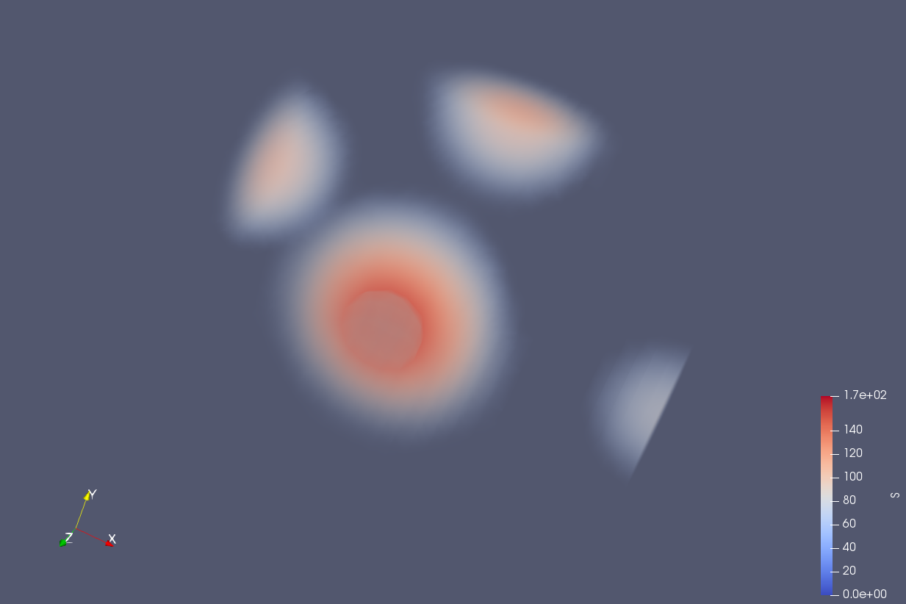

**Isovolume:**

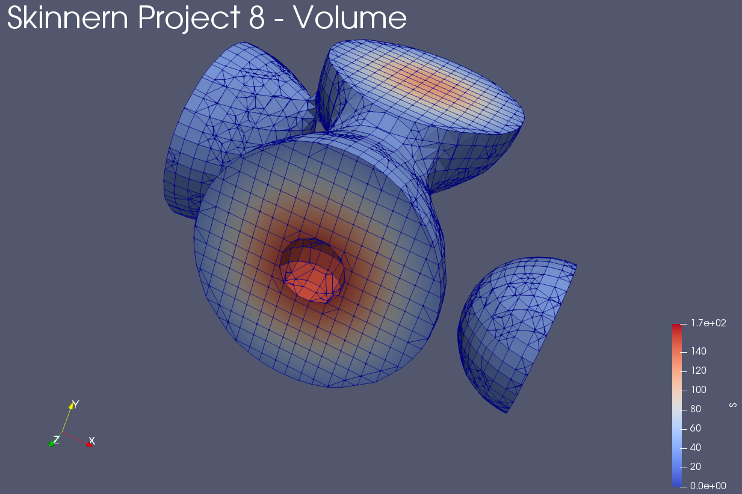

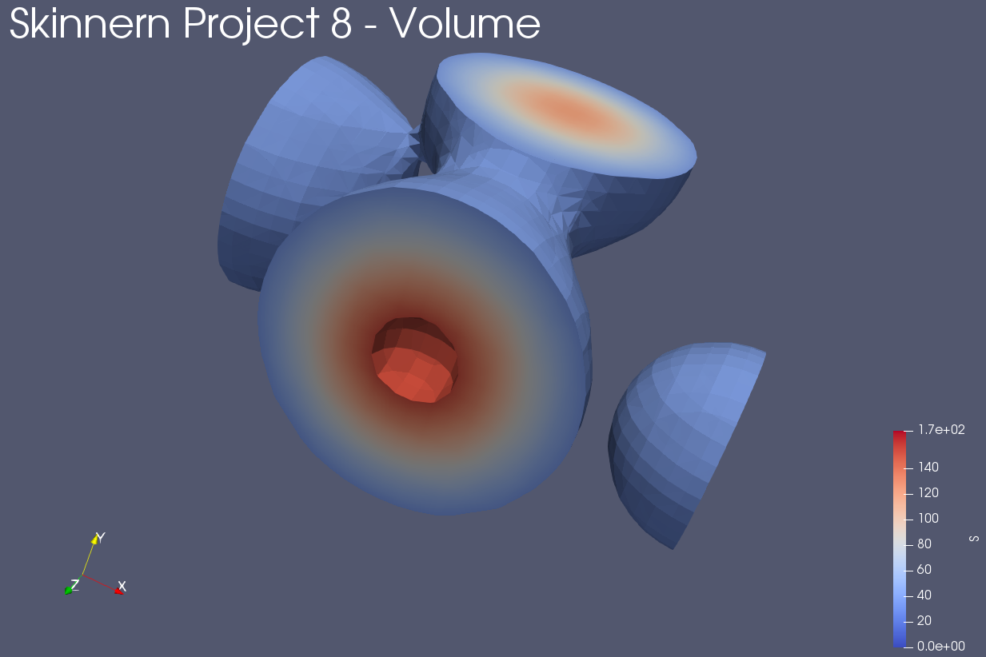

**Isovolume with shrink:**

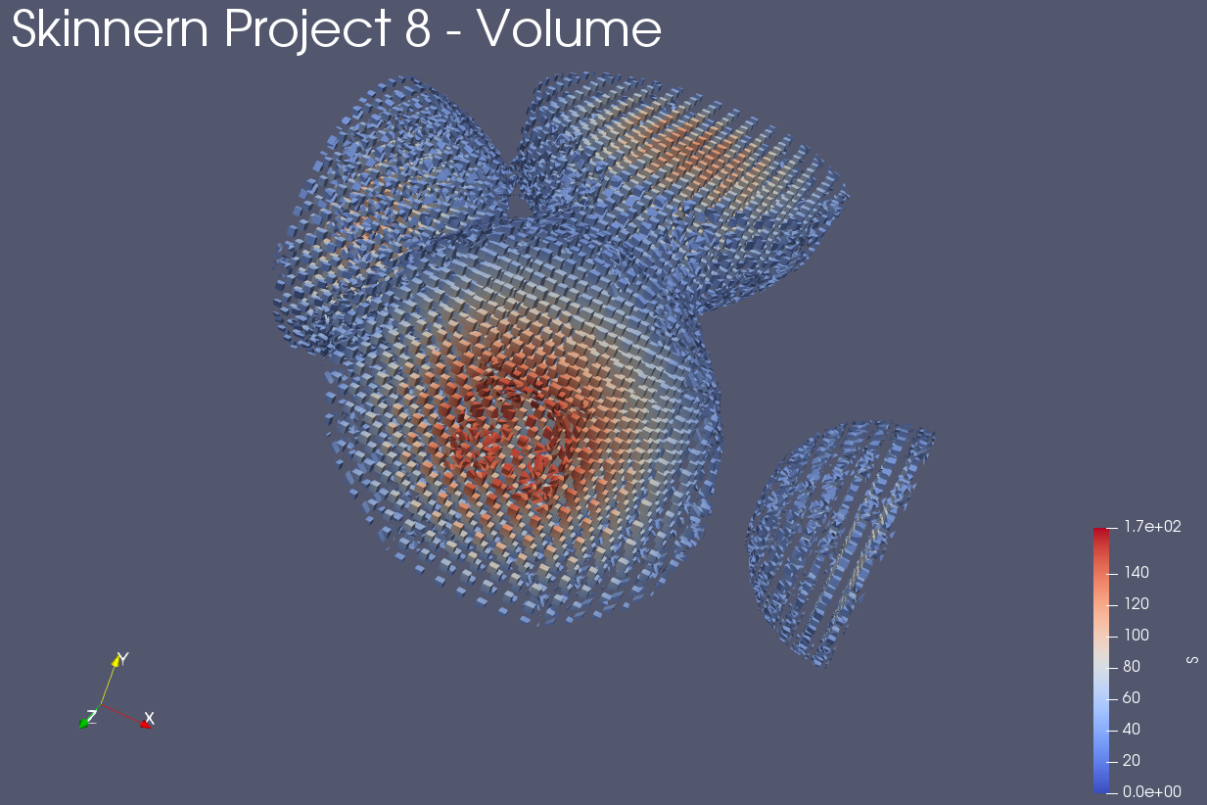

**All with magic lens:**

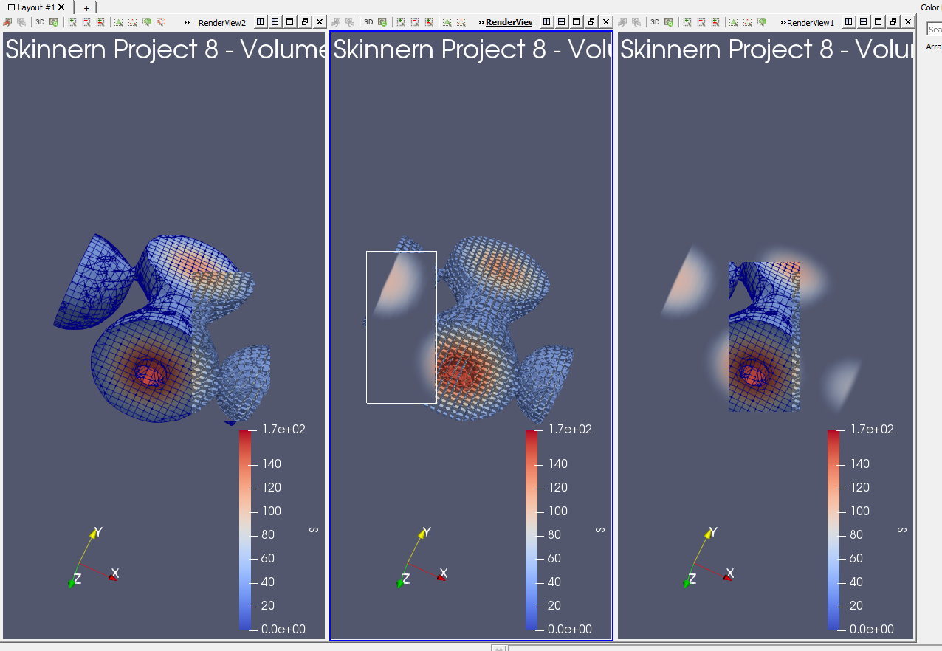

**Commentary:**

I used the basic heat color scale, and made ~70% of the lower level blues transparent. I just thought this would look nice, and cull the non-required segments to make it all look nice.

No video for this submission, as it is not required, and I wasn’t able to move the display on the machine I did the work on without it flickering rapidly.